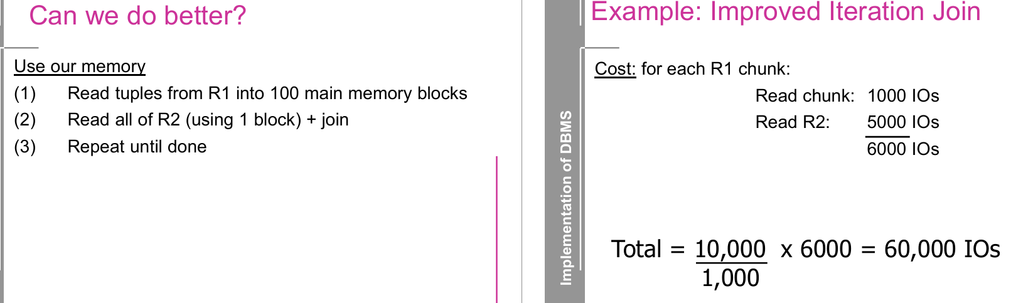
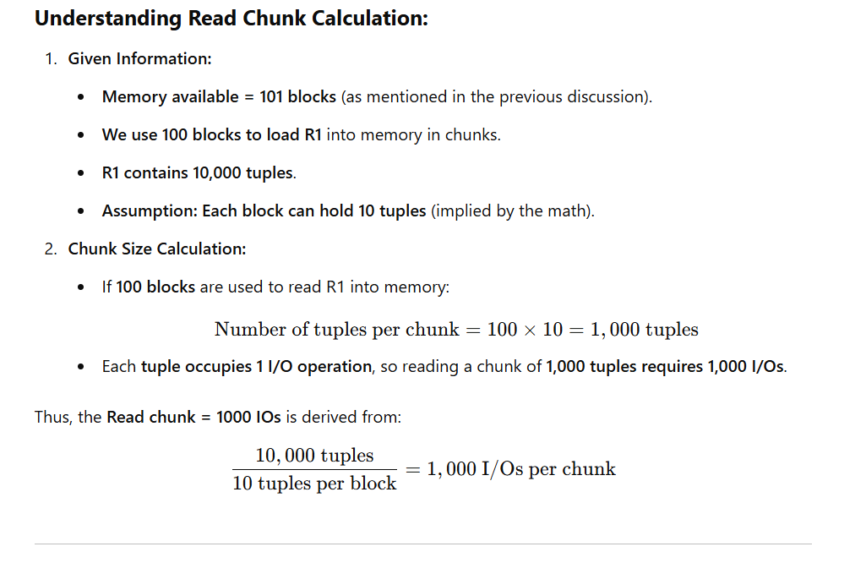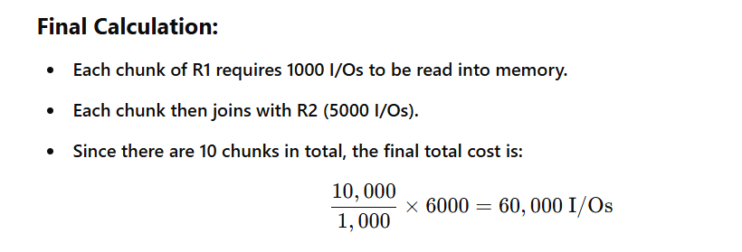

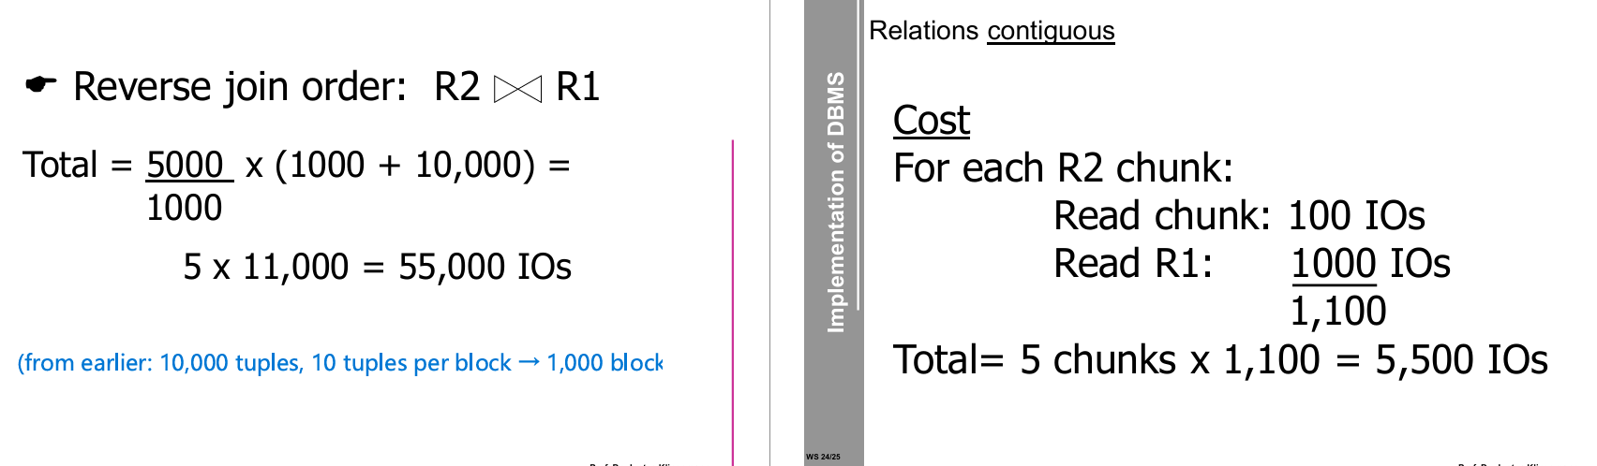

Explanation — the slide shown (block nested-loops, relations contiguous)
Think of the block nested-loops join where we use as much memory as possible to hold chunks of the outer relation and, for each chunk, scan the inner relation once.
Given / assumptions on the slide
- R1 (inner) = 1000 blocks
(from earlier: 10,000 tuples, 10 tuples per block → 1,000 blocks)
- R2 (outer) = 500 blocks
- Memory M = 101 blocks → we can use M − 1 = 100 blocks to hold an outer chunk (one buffer is left for reading the inner)
- Relations are contiguous (sequential scans are cheap)

Step-by-step reasoning (where the numbers come from)
- Chunk size for the outer relation = M − 1 = 100 blocks.
So we partition R2 into chunks of 100 blocks each.
- Number of chunks = ceil(B(R2) / (M−1)) = ceil(500 / 100) = 5 chunks.
- For each chunk we do:
  - Read the chunk from disk into memory once → 100 I/Os (one IO per block in the chunk).
  - Then scan the entire inner relation R1 and probe/join against the in-memory chunk → 1000 I/Os (read the 1000 blocks of R1 sequentially).
  - So cost per chunk = 100 + 1000 = 1,100 I/Os.
- Multiply by the number of chunks:
  - Total = 5 × 1,100 = 5,500 I/Os.
This matches the slide:
For each R2 chunk: Read chunk: 100 IOs | Read R1: 1000 IOs → chunk cost 1100 → 5 chunks × 1100 = 5500 IOs.

Compact formula (useful for exams)
If B_outer = #blocks of outer relation, B_inner = #blocks of inner relation, M = memory buffers:
num_chunks = ceil(B_outer / (M − 1))
IOs_total = B_outer + num_chunks × B_inner
(Explanation: B_outer accounts for reading all outer blocks once across the chunks; num_chunks × B_inner accounts for scanning the inner relation once per chunk.)
Plugging numbers: 500 + 5×1000 = 5500.

Notes / tips
- We assumed contiguous storage (sequential scans). If blocks were scattered/random, the cost model and constants change (more expensive).
- You usually pick the relation that minimizes ceil(B/(M−1)) as outer (often the smaller relation) to reduce scans of the inner.
- If you swapped roles (R1 outer), with B_outer=1000, num_chunks=ceil(1000/100)=10 → IOs = 1000 + 10×500 = 6000 (worse).

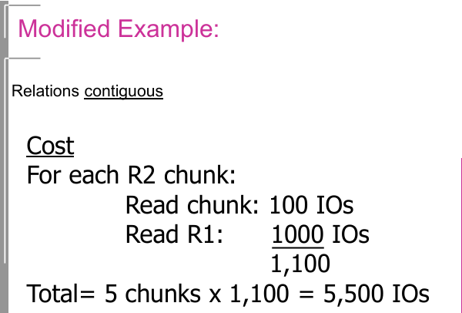

🟦 Step 1. Understanding the Running Example
We are joining R1 ⋈ R2 on a common attribute C.
Parameter | Meaning | Value
T(R1) | Number of tuples in R1 | 10,000
T(R2) | Number of tuples in R2 | 5,000
S(R1), S(R2) | Tuple size | 1/10 of a block
Memory available (M) | Number of memory blocks | 101

🧮 Calculate blocks per relation
If each block holds 10 tuples (since size = 1/10 block per tuple):
B(R1) = 10,000 / 10 = 1,000
So:
- R1 occupies 1000 blocks
- R2 occupies 500 blocks
- Memory = 101 blocks

🟩 Step 2. Which join algorithm is being used?
This is a Block Nested Loop Join (BNLJ).
We will use R2 as the outer relation (the one divided into chunks).
R1 will be the inner relation, read completely for each chunk of R2.

🟨 Step 3. Number of outer chunks
We can keep M – 1 = 100 blocks for the outer relation R2.
So we can load 100 blocks of R2 at once into memory.
Since R2 has 500 blocks:
of chunks} = 500 / 100 = 5
We will have 5 outer iterations.

🟦 Step 4. Cost per outer iteration
For each chunk of R2:
- Read 100 blocks of R2 → 100 I/Os
- Then scan the entire R1 (inner relation) → 1000 I/Os
So total I/O per iteration:
100 + 1000 = 1,100

🟧 Step 5. Total cost
We have 5 chunks, and each chunk costs 1,100 I/Os:
Total I/Os} = 5 × 1,100 = 5,500
✅ Final Answer: 5,500 I/Os

🟩 Step 6. Why it’s called “Modified Example — Contiguous”
The term “relations contiguous” means both R1 and R2 are stored sequentially on disk, so reading a block takes 1 I/O per block (no random-access overhead).
That’s why the cost is computed directly using the number of blocks, not tuples.

🧠 Intuitive Summary
Step | Operation | Explanation
1 | Divide R2 into chunks | Memory can hold 100 blocks → 5 chunks
2 | For each chunk | Read that R2 chunk (100 I/Os) + read full R1 (1000 I/Os)
3 | Total | (5 × 1100 = 5500) I/Os
4 | Metric | We ignore writing the result (only reading cost is counted)

🧩 Key Idea:
- The outer relation (R2) is processed in parts because memory can’t hold all of it.
- The inner relation (R1) must be read once for each outer part.
- Using contiguous storage means I/O count equals the total number of blocks read, with no extra cost for random seeks.

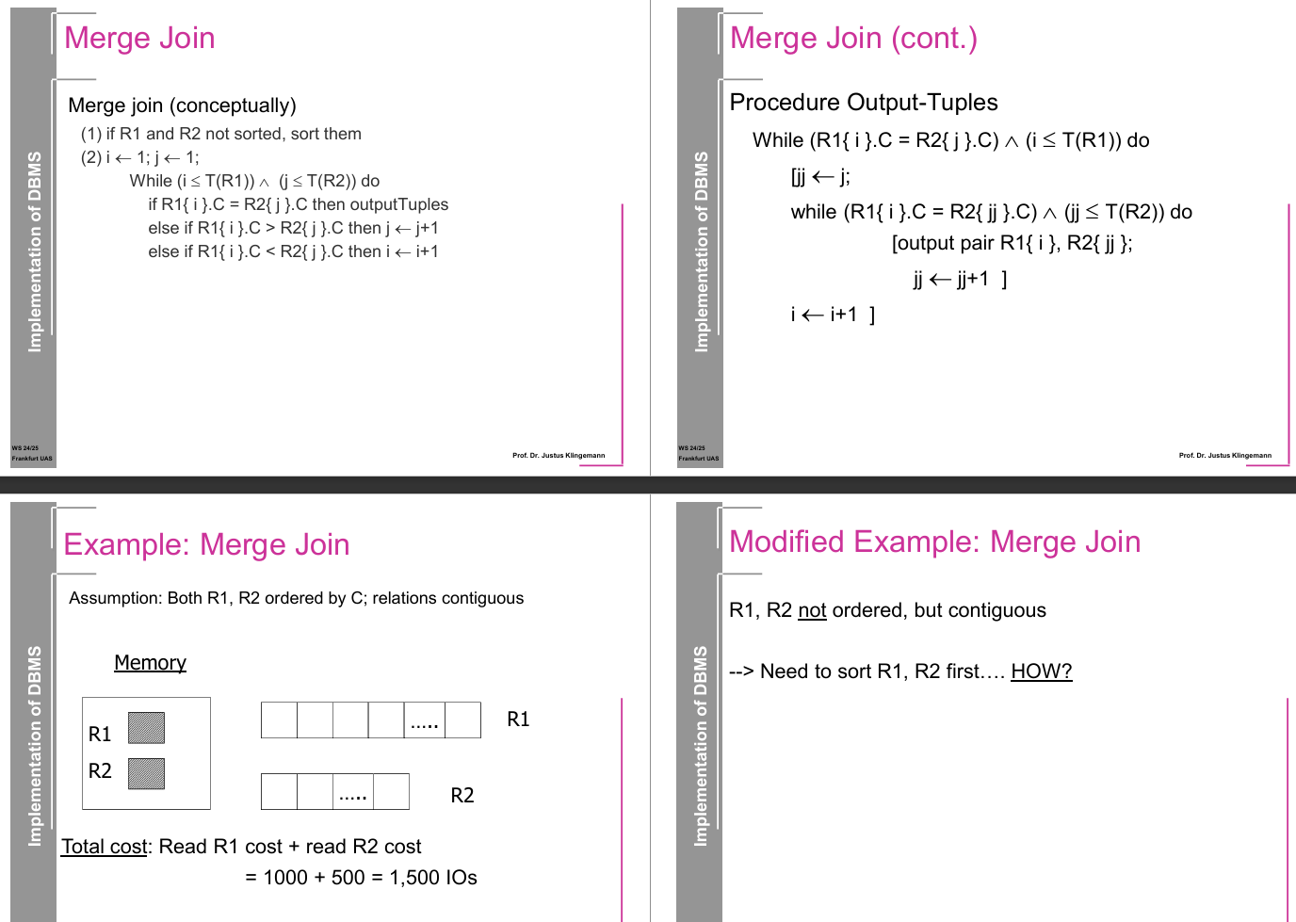

Left Side: Merge Join (Conceptually)
This outlines the high-level logic of the Merge Join:

Step-by-step Explanation:
- Sorting Requirement
If relations R1 and R2 are not sorted on the join attribute (C), sort them.
- Initialize Pointers
Set:
  - i ← 1 (pointer for R1)
  - j ← 1 (pointer for R2)
- Merge Loop
While both pointers are within bounds of their respective tables:
  - If R1[i].C = R2[j].C:
→ output the matching tuples (they have the same join attribute)
  - Else if R1[i].C > R2[j].C:
→ advance j (R2 is behind, try next R2 tuple)
  - Else if R1[i].C < R2[j].C:
→ advance i (R1 is behind, try next R1 tuple)
This loop ensures you walk through both sorted tables efficiently, leveraging the order.

Right Side: Merge Join (cont.): Procedure Output-Tuples
This part describes how to output all matching tuples when a match is found (i.e., R1[i].C = R2[j].C).

Detailed Explanation:
- When a match is found (R1[i].C = R2[j].C), we:
  - Set jj ← j (start scanning from current j position)
  - Enter a nested loop to check all subsequent matching R2[jj] tuples
    - While R1[i].C = R2[jj].C and jj ≤ T(R2):
→ output the pair R1[i], R2[jj]
→ increment jj
- After all matches for R1[i] are output, advance i ← i + 1
This ensures that if there are multiple tuples in R2 with the same value as R1[i], all combinations are output.

🔁 Summary of Merge Join Workflow:
- Works best when both relations are sorted.
- Walks through both using pointers i and j.
- When a match is found:
  - Outputs all matching tuples from R2 for that R1[i].
- Moves forward depending on comparison results:
  - If R1[i].C < R2[j].C → move i forward
  - If R1[i].C > R2[j].C → move j forward

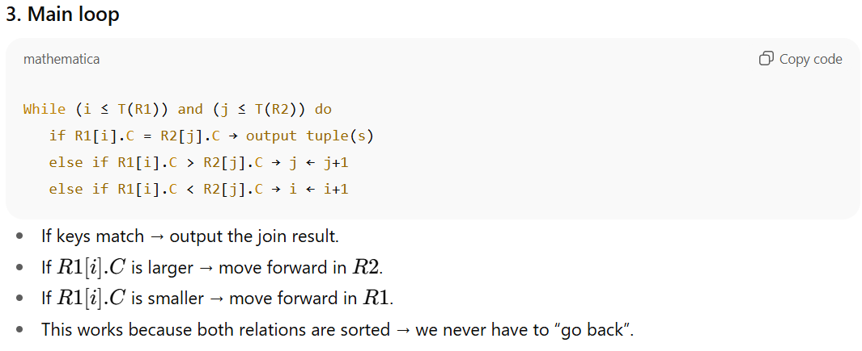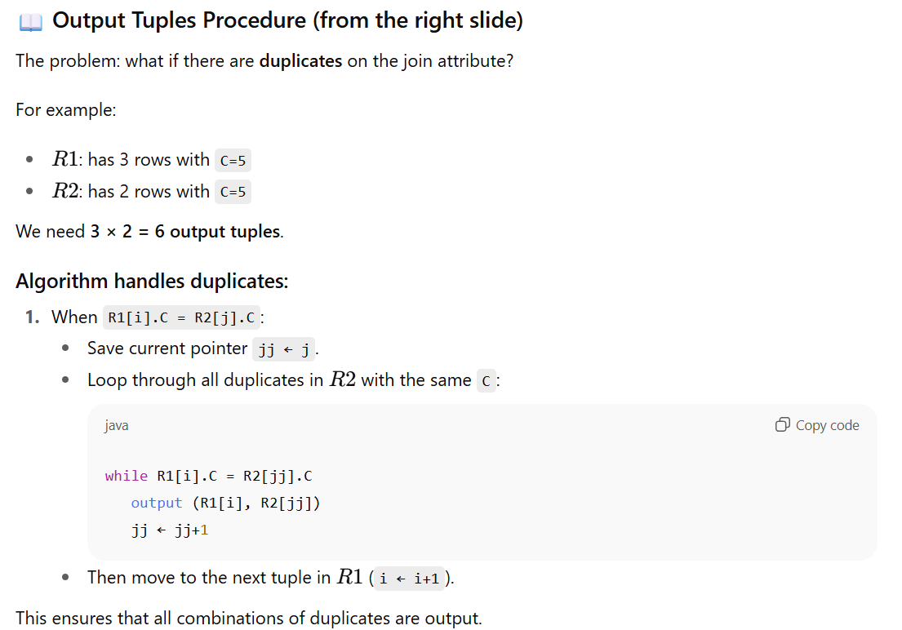
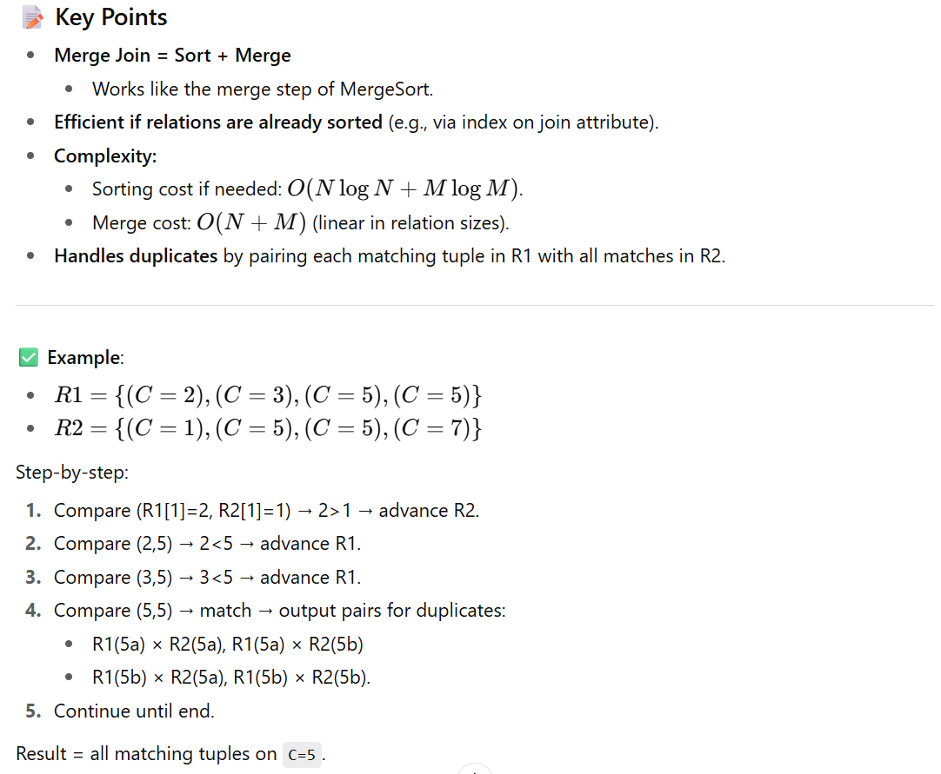
👉 So, Merge Join is basically:
- Sort both inputs (if needed).
- Walk through them in order, advancing pointers based on comparison.
- When equal, output all combinations of duplicates.
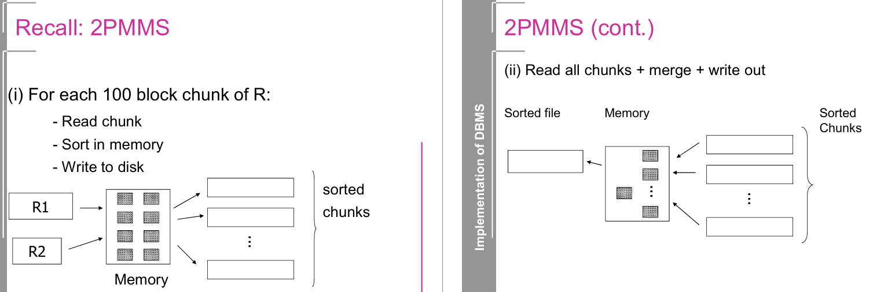
the Two-Phase Multiway Merge Sort (2PMMS) using your slides.

🔑 What is 2PMMS?
It’s the standard external sorting algorithm used in DBMS when relations are too large to fit in memory.
- “Two-Phase” → it runs in 2 passes over the data.
- “Multiway” → during merging, we can merge many chunks at once (not just 2).

📖 Phase 1: Create sorted runs (left slide)
For each chunk of relation R:
- Read a chunk into memory (e.g., 100 blocks at a time, limited by buffer size).
- Sort it in memory (using quicksort or heapsort).
- Write the sorted chunk back to disk.
After this step:
- The relation is broken into sorted runs (sorted chunks), each written to disk.
- Example: If R = 1000 blocks and memory = 100 blocks, then we get 1000 / 100 = 10 sorted runs.

📖 Phase 2: Merge sorted runs (right slide)
- Read all runs into memory (one block from each run at a time).
- Use a k-way merge algorithm:
  - Keep one input buffer per run.
  - Compare the first element of each buffer.
  - Output the smallest (or according to order).
  - Refill the buffer when it gets empty.
- Write merged output to disk.
At the end:
- You get one fully sorted file.

📝 Key Points
- Why “multiway” merge?
  - Instead of merging only 2 runs at a time (like in mergesort), we merge as many as memory allows.
  - If memory holds M blocks, we can merge up to M-1 runs in one go (because 1 buffer is needed for output).
- I/O Cost of 2PMMS:
  - Every block is read twice and written twice:
    - Phase 1: read unsorted data, write sorted runs.
    - Phase 2: read runs, write final sorted file.
  - Total = 4×B(R), where B(R) = number of blocks in relation R.
- Memory requirement:
  - Works as long as the number of runs ≤ (number of memory blocks – 1).
  - Otherwise, more than 2 passes are needed.

✅ Example Walkthrough
Suppose:
- Relation R = 1000 blocks.
- Memory = 100 blocks.
Phase 1:
- Read 100 blocks at a time → sort → write out.
- Creates 10 sorted runs of 100 blocks each.
Phase 2:
- Use memory to hold 1 block from each of the 10 runs + 1 output buffer.
- Multiway merge them into one sorted file of 1000 blocks.
Total cost:
- Phase 1: 1000 reads + 1000 writes
- Phase 2: 1000 reads + 1000 writes
- = 4000 I/Os

👉 So in simple words:
2PMMS = make sorted chunks (pass 1) + merge them in one go (pass 2).

Merge Join vs. Iteration Join
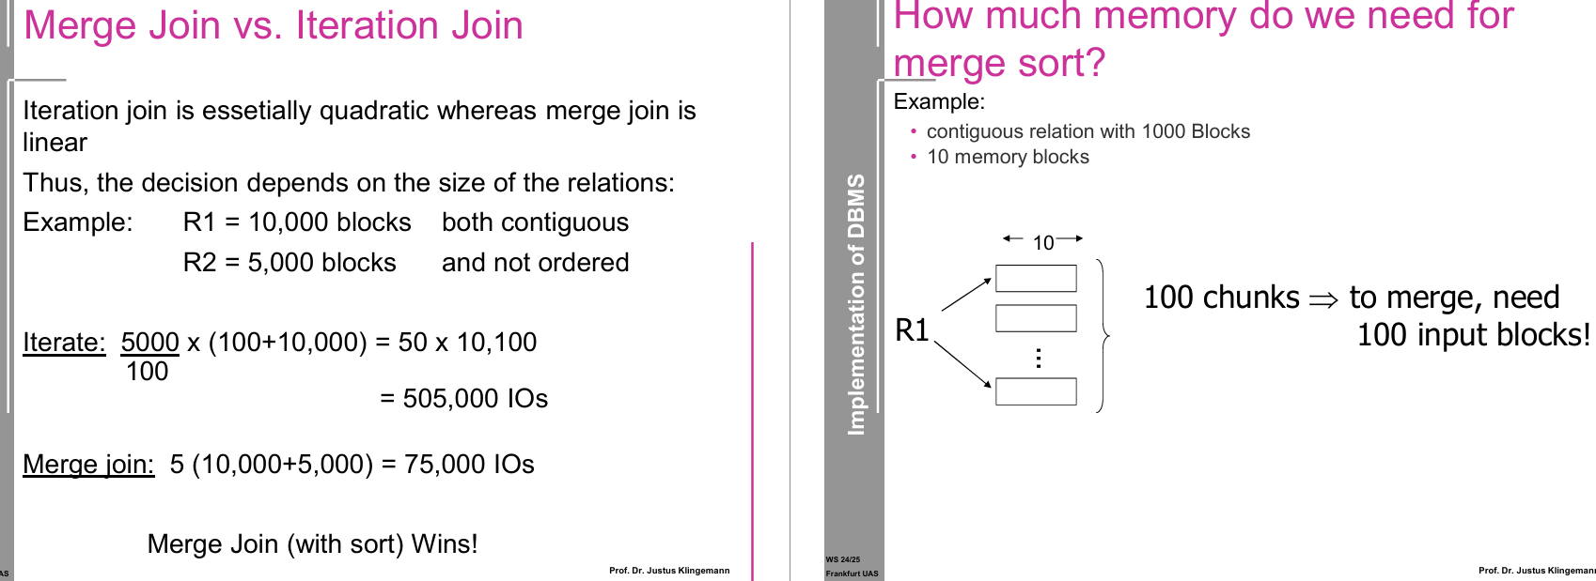

🔹 Left Slide: Merge Join vs Iteration Join

1. Iteration Join (Nested Loop Join)
- For every tuple (or block) in relation R2, we scan relation R1.
- Cost is quadratic in size of the relations.
👉 Example:
- R1 = 10,000 blocks
- R2 = 5,000 blocks
- Memory = 100 blocks
I/O cost:
5000/100×(100+10,000)=50×10,100=505,000
💡 Why divide by 100?
- Because memory can hold 100 blocks at a time, so 5000/100 = 50 iterations needed.

2. Merge Join
- Works if both relations are sorted on join attribute (or we sort them first).
- Algorithm:
  - Merge two sorted relations (like merging in merge sort).
  - Linear complexity (just scan both once).
I/O cost:
5×(10,000+5,000)=75,000
💡 Why factor 5?
- Represents the merge passes when memory can handle multiple blocks at once (depends on buffer size).

✅ Conclusion:
- Iteration Join → very expensive (quadratic).
- Merge Join → much cheaper (linear).
- Merge Join wins when relations are large.

🔹 Right Slide: Memory for Merge Sort
Example:
- Relation = 1000 blocks
- Memory = 10 blocks

Step 1: Phase 1 (create sorted runs)
- Each run = 10 blocks (fit in memory).
- Total runs = 1000 / 10 = 100.

Step 2: Phase 2 (merge runs)
- To merge 100 runs → we need 100 input buffers (one per run) + 1 output buffer.
- But memory = only 10 blocks → cannot merge all runs in one pass.
⚠️ Problem: Too many runs to merge with limited memory.
- With 10 memory blocks, you can only merge 9 runs at a time (since 1 block is for output).
- So → requires multiple merge passes (more than 2 phases).

✅ Key Exam Points
- Iteration Join: Nested loops, quadratic I/O cost.
- Merge Join: Linear cost if sorted (or after external sort).
- 2PMMS memory rule: To merge in 2 passes,
M - 1
where M = number of memory blocks.
👉 In this example:
- Runs = 100
- Memory = 10 → can only handle 9 runs
- So needs extra passes (more than 2 phases).

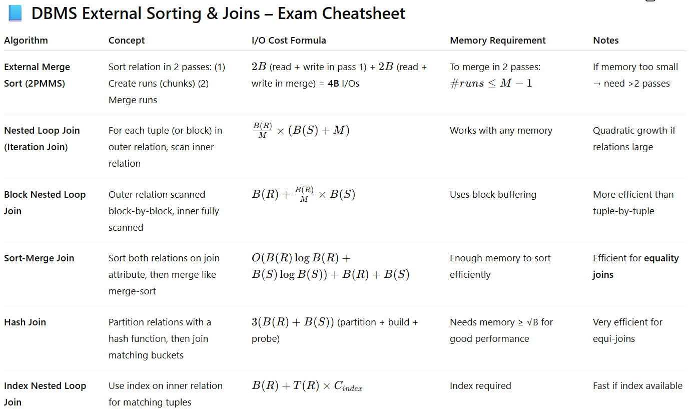
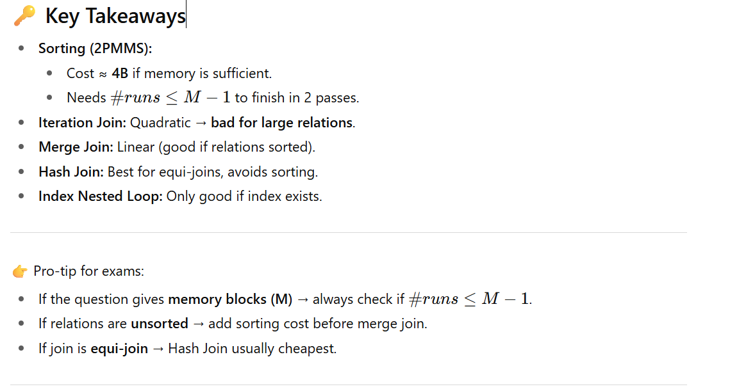

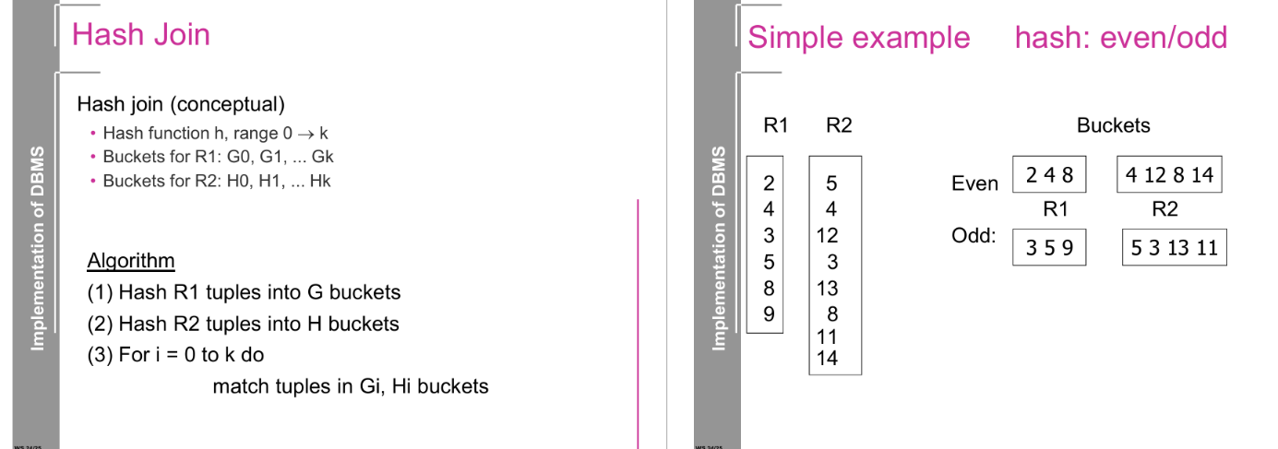

🔹 1. What is Hash Join?
- A join algorithm that partitions both relations using a hash function.
- Then, only tuples that fall into the same hash bucket are compared.
- This avoids comparing every tuple in R with every tuple in S (like nested loop).

🔹 2. Algorithm (from slide)
- Hash Phase (Partitioning):
  - Apply hash function h to tuples of R, distribute into buckets G0, G1, … Gk.
  - Apply same hash function h to tuples of S, distribute into buckets H0, H1, … Hk.
- Probe Phase (Matching):
  - For each bucket index i:
    - Join tuples in Gi (from R) with tuples in Hi (from S).
  - Since only tuples in the same bucket share the same hash value, only they can match.
✅ Cost: ~ B(R) + B(S) (linear in input size).

🔹 3. Simple Example (even/odd hash function)
Here the hash function is:
h(x)=x mod 2
So two buckets: Even and Odd.

Relation R1: {2, 4, 3, 5, 8, 9}
- Even bucket → {2, 4, 8}
- Odd bucket → {3, 5, 9}

Relation R2: {5, 4, 12, 3, 13, 8, 11, 14}
- Even bucket → {4, 12, 8, 14}
- Odd bucket → {5, 3, 13, 11}

Now join is done bucket by bucket:
- Even buckets: Join {2,4,8} with {4,12,8,14}
- Odd buckets: Join {3,5,9} with {5,3,13,11}

🔑 Key Insights
- Partitioning ensures we never compare an even with an odd → fewer comparisons.
- Within each bucket, we still perform comparisons, but buckets are much smaller than the original relations.
- Works best when:
  - The hash function distributes tuples uniformly (avoiding skew).
  - Enough memory exists to hold at least one bucket at a time.

Example Hash Join
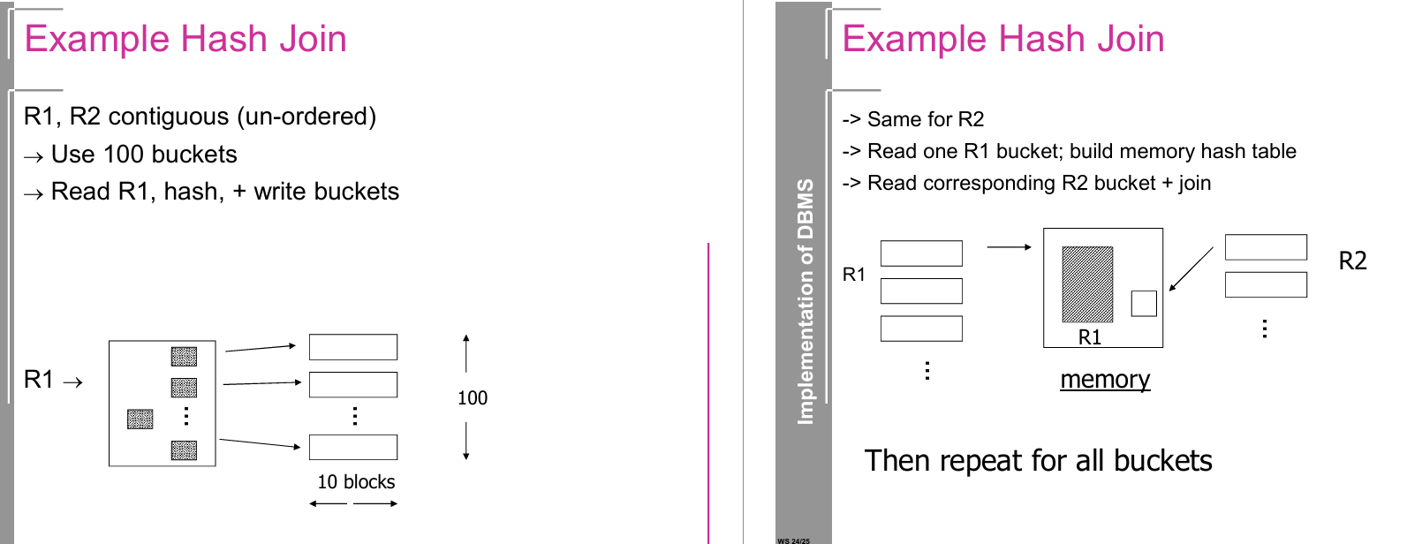

🔹 Hash Join Phases (from the slides)

1. Partition Phase
- Suppose we have R1 and R2, each stored contiguously on disk.
- We pick a hash function h(x).
- We allocate 100 buckets (in this example).
Process for R1:
- Read R1 block by block.
- Apply hash function to each tuple.
- Write tuple into the appropriate bucket (on disk).
👉 Now R1 is split into 100 disk buckets.
👉 Repeat the same for R2 → also 100 buckets.
💡 Why? Because tuples with the same join key must fall into the same bucket in both R1 and R2.

2. Probe (Join) Phase
- For each bucket index i (0..99):
  - Load bucket R1_i into memory.
  - Build an in-memory hash table for it.
  - Read the corresponding bucket R2_i.
  - For each tuple in R2_i, probe the hash table of R1_i.
  - Output matching pairs.
👉 Then repeat this for all 100 buckets.

🔹 Key Characteristics
- I/O Cost:
  - Partitioning:
    - Read R1 and write into buckets → 2 × B(R1) I/Os.
    - Read R2 and write into buckets → 2 × B(R2) I/Os.
  - Probing:
    - Read each bucket once → B(R1) + B(R2).
Total ≈ 3 × (B(R1) + B(R2)) I/Os.
Much cheaper than nested loop join.
- Memory Use:
  - Need enough memory to hold one partition of R1 at a time.
  - If a bucket is too big to fit in memory, recursive partitioning is applied.
- Advantage:
  - Works very well if data is evenly distributed by hash function.
  - Linear in input size.
- Drawback:
  - Sensitive to skew (if many tuples hash to the same bucket).
  - Requires multiple passes if buckets don’t fit in memory.

🔑 Intuition from the Slide
- Left side (Partition): Break R1 into 100 buckets of about 10 blocks each. Same for R2.
- Right side (Probe): For each bucket →
  - Bring R1_i into memory,
  - Build hash table,
  - Stream tuples of R2_i,
  - Perform join matches.

✅ That’s the block-level hash join algorithm in practice.

Example of Hashing Process
Consider R1 and R2 containing the following tuples:

R1 Tuples:
(ID: 2, Name: A), (ID: 4, Name: B), (ID: 3, Name: C), (ID: 5, Name: D)

R2 Tuples:
(ID: 5, Dept: X), (ID: 4, Dept: Y), (ID: 3, Dept: Z), (ID: 8, Dept: W)
If we use a modulus hash function (ID % 2), the bucket assignment would be:
- Even Bucket: {ID: 2, ID: 4} (from R1) and {ID: 4, ID: 8} (from R2)
- Odd Bucket: {ID: 3, ID: 5} (from R1) and {ID: 3, ID: 5} (from R2)
Each bucket is processed separately, ensuring efficient and scalable join operations.

Conclusion
The hash join algorithm is particularly useful for large unindexed relations. The bucket-based processing ensures that tuples are efficiently joined with minimal memory overhead, making it faster than nested-loop joins and more scalable for large datasets.

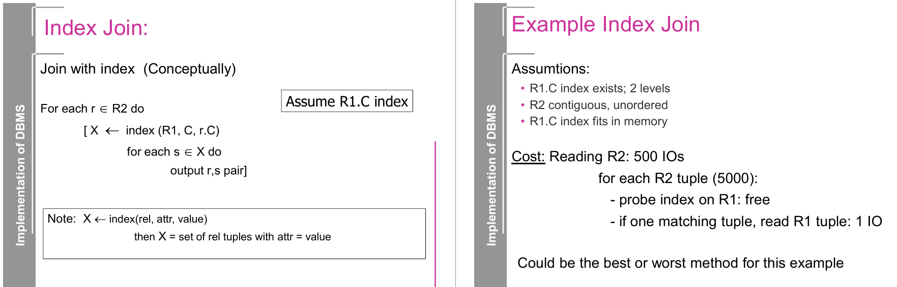

Index Join: Concept and Explanation
The Index Join, also known as Index Nested Loop Join (INLJ), is a join algorithm that utilizes an index to efficiently retrieve matching tuples from one relation while iterating over the other relation. This method is beneficial when an index exists on the join attribute of one of the relations, as it allows for fast lookups.

Conceptual Steps (Based on Image)
- Iterate over each tuple in relation R2 (the outer relation).
- Use the index on R1 (inner relation) to find matching tuples.
  - The lookup operation retrieves all tuples from R1 where the join attribute matches the attribute value in the current tuple of R2.
- Output the matching pairs of tuples from R1 and R2.

Example from the Image

Assumptions
- R1 has an index on attribute C.
- The index has 2 levels (i.e., a B+ tree with two levels).
- R2 is contiguous but unordered.
- The index on R1 fits in memory, allowing efficient lookups.

Cost Analysis
- Reading R2 requires 500 I/Os.
- For each tuple in R2 (5000 tuples),
  - Probing the index on R1 is free (since the index is in memory).
  - If one matching tuple exists, an additional 1 I/O is needed to read the tuple from R1.
  - Total I/O cost = 500 (R2 scan) + 5000 (R1 accesses) = 5500 I/Os.
- Performance Consideration:
  - Best case: If the index lookup is highly selective and minimizes I/Os.
  - Worst case: If every tuple in R2 has multiple matches in R1, leading to a high I/O cost.

Comparison with Other Join Methods
- Nested Loop Join (NLJ):
  - Without an index, NLJ requires scanning R1 for each tuple in R2, leading to O(|R1| * |R2|) I/O complexity, which is inefficient.
- Merge Join:
  - Requires both relations to be sorted on the join key.
  - Typically performs better than Index Join when dealing with large, contiguous relations.
- Hash Join:
  - Works well for large, unordered datasets, especially when there is no index available.

When to Use Index Join?
- When an index exists on the join attribute of one relation.
- When the index fits in memory, allowing fast lookups.
- When the outer relation (R2) is small or scanned efficiently.
- When the inner relation (R1) is large but indexed, avoiding full scans.

Conclusion
The Index Join is an efficient method for joining relations when an index is available, as it significantly reduces the number of disk accesses. However, its efficiency depends on index selectivity, memory availability, and the distribution of matching tuples. It may be outperformed by Merge Join or Hash Join when dealing with large relations without indexing.

